Adf:
This Documentation helps you understand pipelines and activities in Azure Data Factory and use them to construct end-to-end data-driven workflows for your data movement and data processing scenarios.

Azure Data Factory is the platform that solves such data scenarios. It is the cloud-based ETL and data integration service that allows you to create data-driven workflows for orchestrating data movement and transforming data at scale. Using Azure Data Factory, you can create and schedule data-driven workflows (called pipelines) that can ingest data from disparate data stores. You can build complex ETL processes that transform data visually with data flows or by using compute services such as Azure HDInsight Hadoop, Azure Databricks, and Azure SQL Database.

How does it work?
Data Factory contains a series of interconnected systems that provide a complete end-to-end platform for data engineers.
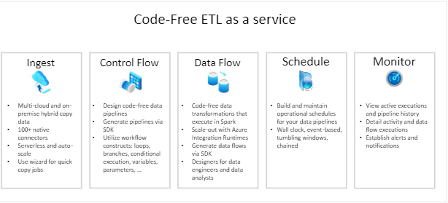

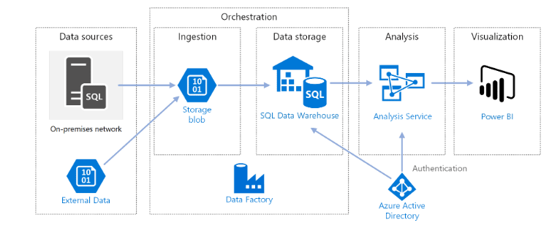

Connect and collect
Enterprises have data of various types that are located in disparate sources on-premises, in the cloud, structured, unstructured, and semi-structured, all arriving at different intervals and speeds.
The first step in building an information production system is to connect to all the required sources of data and processing, such as software-as-a-service (SaaS) services, databases, file shares, and FTP web services. The next step is to move the data as needed to a centralized location for subsequent processing.
Without Data Factory, enterprises must build custom data movement components or write custom services to integrate these data sources and processing. It's expensive and hard to integrate and maintain such systems. In addition, they often lack the enterprise-grade monitoring, alerting, and the controls that a fully managed service can offer.
With Data Factory, you can use the Copy Activity in a data pipeline to move data from both on-premises and cloud source data stores to a centralization data store in the cloud for further analysis.

Transform and enrich
After data is present in a centralized data store in the cloud, process or transform the collected data by using ADF mapping data flows. Data flows enable data engineers to build and maintain data transformation graphs that execute on Spark without needing to understand Spark clusters or Spark programming.
If you prefer to code transformations by hand, ADF supports external activities for executing your transformations on compute services such as HDInsight Hadoop, Spark, Data Lake Analytics, and Machine Learning.

CI/CD and publish
Data Factory offers full support for CI/CD of your data pipelines using Azure DevOps and GitHub. This allows you to incrementally develop and deliver your ETL processes before publishing the finished product. After the raw data has been refined into a business-ready consumable form, load the data into Azure Data Warehouse, Azure SQL Database, Azure Cosmos DB, or whichever analytics engine your business users can point to from their business intelligence tools.

Monitor
After you have successfully built and deployed your data integration pipeline, providing business value from refined data, monitor the scheduled activities and pipelines for success and failure rates. Azure Data Factory has built-in support for pipeline monitoring via Azure Monitor, API, PowerShell, Azure Monitor logs, and health panels on the Azure portal.

Top-level concepts
An Azure subscription might have one or more Azure Data Factory instances (or data factories). Azure Data Factory is composed of the following key components:
- Pipelines
- Activities
- Datasets
- Linked services
- Data Flows
- Integration Runtimes
These components work together to provide the platform on which you can compose data-driven workflows with steps to move and transform data.

Pipeline
A data factory might have one or more pipelines. A pipeline is a logical grouping of activities that performs a unit of work. Together, the activities in a pipeline perform a task. The activities in a pipeline can be chained together to operate sequentially, or they can operate independently in parallel.

Mapping data flows
Create and manage graphs of data transformation logic that you can use to transform any-sized data. You can build-up a reusable library of data transformation routines and execute those processes in a scaled-out manner from your ADF pipelines. Data Factory will execute your logic on a Spark cluster that spins-up and spins-down when you need it. You won't ever have to manage or maintain clusters.

Activity
Activities represent a processing step in a pipeline. For example, you might use a copy activity to copy data from one data store to another data store. Similarly, you might use a Hive activity, which runs a Hive query on an Azure HDInsight cluster, to transform or analyze your data. Data Factory supports three types of activities: data movement activities, data transformation activities, and control activities.

Datasets
Datasets represent data structures within the data stores, which simply point to or reference the data you want to use in your activities as inputs or outputs.

Linked services
Linked services are much like connection strings, which define the connection information that's needed for Data Factory to connect to external resources. Think of it this way: a linked service defines the connection to the data source, and a dataset represents the structure of the data.
Linked services are used for two purposes in Data Factory:
1.To represent a data store that includes, but isn't limited to, a SQL Server database, Oracle database, file share, or Azure blob storage account. For a list of supported data stores.
2. To represent a compute resource that can host the execution of an activity. For example, the HDInsightHive activity runs on an HDInsight Hadoop cluster. For a list of transformation activities and supported compute environments.

Integration Runtime
In Data Factory, an activity defines the action to be performed. A linked service defines a target data store or a compute service. An integration runtime provides the bridge between the activity and linked Services. It's referenced by the linked service or activity, and provides the compute environment where the activity either runs on or gets dispatched from. This way, the activity can be performed in the region closest possible to the target data store or compute service in the most performant way while meeting security and compliance needs.

Triggers
Triggers represent the unit of processing that determines when a pipeline execution needs to be kicked off. There are different types of triggers for different types of events.

Pipeline runs
A pipeline run is an instance of the pipeline execution. Pipeline runs are typically instantiated by passing the arguments to the parameters that are defined in pipelines. The arguments can be passed manually or within the trigger definition.

Parameters
Parameters are key-value pairs of read-only configuration. Parameters are defined in the pipeline. The arguments for the defined parameters are passed during execution from the run context that was created by a trigger or a pipeline that was executed manually. Activities within the pipeline consume the parameter values.
A dataset is a strongly typed parameter and a reusable/referenceable entity. An activity can reference datasets and can consume the properties that are defined in the dataset definition.
A linked service is also a strongly typed parameter that contains the connection information to either a data store or a compute environment. It is also a reusable/referenceable entity.

Control flow
Control flow is an orchestration of pipeline activities that includes chaining activities in a sequence, branching, defining parameters at the pipeline level, and passing arguments while invoking the pipeline on-demand or from a trigger. It also includes custom-state passing and looping containers, that is, For-each iterators.

Variables
Variables can be used inside of pipelines to store temporary values and can also be used in conjunction with parameters to enable passing values between pipelines, data flows, and other activities.

Data transformation activities

Data Flow activity:

Use the Data Flow activity to transform and move data via mapping data flows.

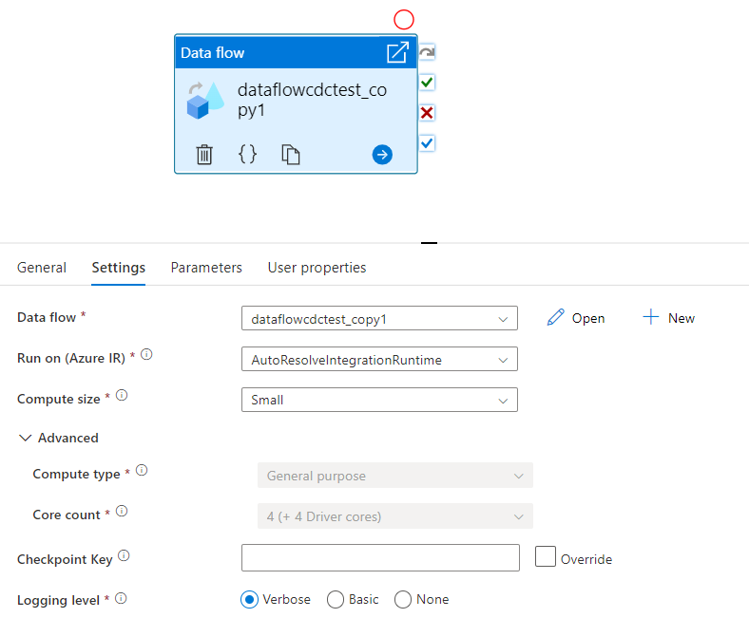

Copy activity:

In Azure Data Factory and Synapse pipelines, you can use the Copy activity to copy data among data stores located on-premises and in the cloud.

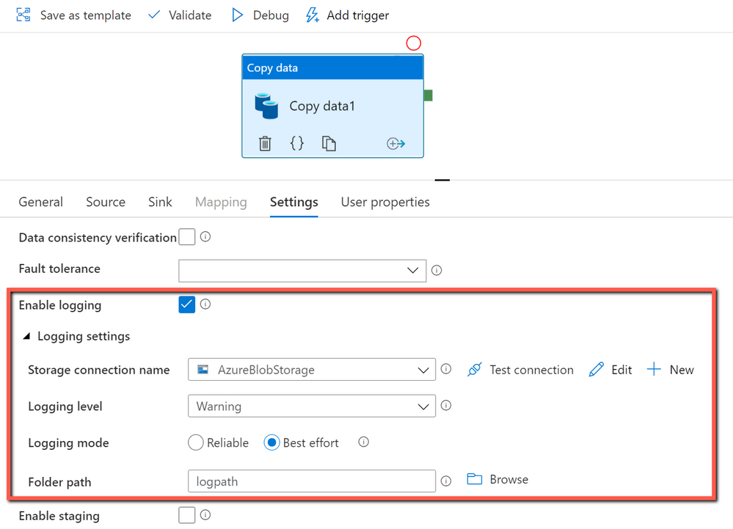

Azure Function activity:

The Azure Function activity allows you to run Azure Functions in an Azure Data Factory.

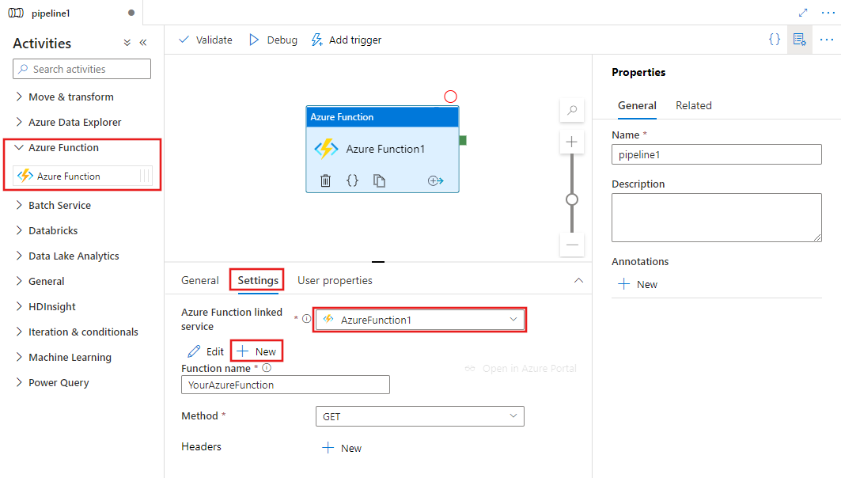

Databricks Notebook Activity:
The Azure Databricks Notebook Activity in a pipeline runs a Databricks notebook in your Azure Databricks workspace.

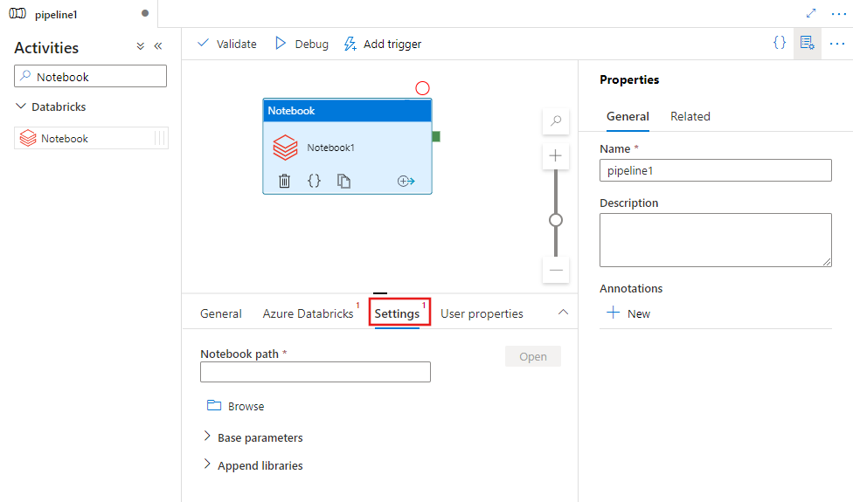

Databricks Notebook activity properties
The following table describes the JSON properties used in the JSON definition:
Expand table
Property | Description | Required
name | Name of the activity in the pipeline. | Yes
description | Text describing what the activity does. | No
type | For Databricks Notebook Activity, the activity type is DatabricksNotebook. | Yes
linkedServiceName | Name of the Databricks Linked Service on which the Databricks notebook runs. To learn about this linked service, see Compute linked services article. | Yes
notebookPath | The absolute path of the notebook to be run in the Databricks Workspace. This path must begin with a slash. | Yes
baseParameters | An array of Key-Value pairs. Base parameters can be used for each activity run. If the notebook takes a parameter that is not specified, the default value from the notebook will be used. Find more on parameters in Databricks Notebooks. | No
libraries | A list of libraries to be installed on the cluster that will execute the job. It can be an array of <string, object>. | No

Databricks Jar Activity:
The Azure Databricks Jar Activity in a pipeline runs a Spark Jar in your Azure Databricks cluster.
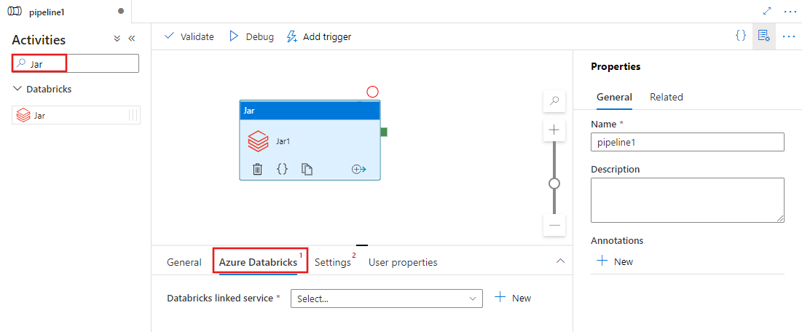

Databricks Jar activity properties
The following table describes the JSON properties used in the JSON definition:
Expand table
Property | Description | Required
name | Name of the activity in the pipeline. | Yes
description | Text describing what the activity does. | No
type | For Databricks Jar Activity, the activity type is DatabricksSparkJar. | Yes
linkedServiceName | Name of the Databricks Linked Service on which the Jar activity runs. To learn about this linked service, see Compute linked services article. | Yes
mainClassName | The full name of the class containing the main method to be executed. This class must be contained in a JAR provided as a library. A JAR file can contain multiple classes. Each of the classes can contain a main method. | Yes
parameters | Parameters that will be passed to the main method. This property is an array of strings. | No
libraries | A list of libraries to be installed on the cluster that will execute the job. It can be an array of <string, object> | Yes (at least one containing the mainClassName method)

Databricks Python Activity:
The Azure Databricks Python Activity in a pipeline runs a Python file in your Azure Databricks cluster.
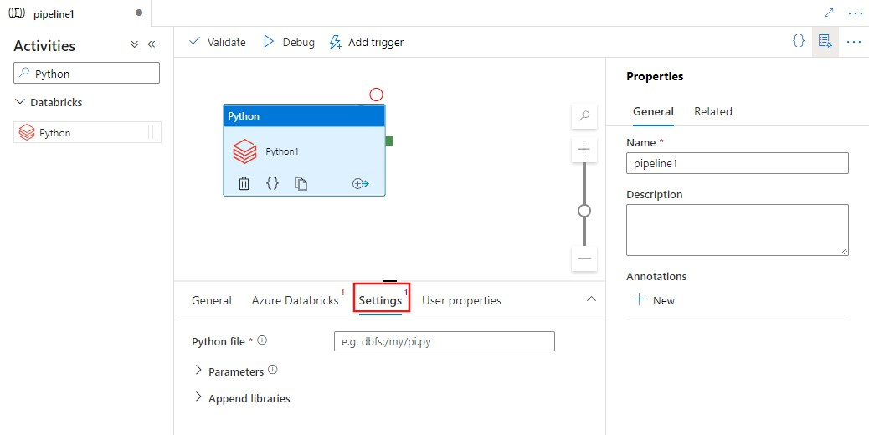
Property | Description | Required
name | Name of the activity in the pipeline. | Yes
description | Text describing what the activity does. | No
type | For Databricks Python Activity, the activity type is DatabricksSparkPython. | Yes
linkedServiceName | Name of the Databricks Linked Service on which the Python activity runs. To learn about this linked service, see Compute linked services article. | Yes
pythonFile | The URI of the Python file to be executed. Only DBFS paths are supported. | Yes
parameters | Command line parameters that will be passed to the Python file. This is an array of strings. | No
libraries | A list of libraries to be installed on the cluster that will execute the job. It can be an array of <string, object> | No

Control activity | Description
Append Variable | Add a value to an existing array variable.
Execute Pipeline | Execute Pipeline activity allows a Data Factory or Synapse pipeline to invoke another pipeline.
Filter | Apply a filter expression to an input array
For Each | ForEach Activity defines a repeating control flow in your pipeline. This activity is used to iterate over a collection and executes specified activities in a loop. The loop implementation of this activity is similar to the Foreach looping structure in programming languages.
Get Metadata | GetMetadata activity can be used to retrieve metadata of any data in a Data Factory or Synapse pipeline.
If Condition Activity | The If Condition can be used to branch based on condition that evaluates to true or false. The If Condition activity provides the same functionality that an if statement provides in programming languages. It evaluates a set of activities when the condition evaluates to true and another set of activities when the condition evaluates to false.
Lookup Activity | Lookup Activity can be used to read or look up a record/ table name/ value from any external source. This output can further be referenced by succeeding activities.
Set Variable | Set the value of an existing variable.
Until Activity | Implements Do-Until loop that is similar to Do-Until looping structure in programming languages. It executes a set of activities in a loop until the condition associated with the activity evaluates to true. You can specify a timeout value for the until activity.
Validation Activity | Ensure a pipeline only continues execution if a reference dataset exists, meets a specified criteria, or a timeout has been reached.
Wait Activity | When you use a Wait activity in a pipeline, the pipeline waits for the specified time before continuing with execution of subsequent activities.
Web Activity | Web Activity can be used to call a custom REST endpoint from a pipeline. You can pass datasets and linked services to be consumed and accessed by the activity.
Webhook Activity | Using the webhook activity, call an endpoint, and pass a callback URL. The pipeline run waits for the callback to be invoked before proceeding to the next activity.

"id"
"projectid"
"sprintid"
"pbiid"
"builddate"
"version"
"buildprovidedby"
"rejectedby"
"createdat"
"updatedat"
"isactive"
"comments"
"isaccept"

